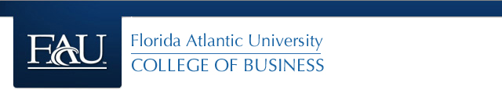

**ISM 6136 – Datamining/Predictive Analytics**

**Dr. Bharti Sharma**

**Class Assignment 8**

**5 points**

**TASK: Performing Association – Data Mining Task using XLMiner**

(Note: Check Support A & C together and not individual support).

1. Charles_Book_Club – Determine which group of books will likely to be purchased based on given data. Determine at least 3 strongest association rules. Remember the rules you select should not have the exactly same combination of Antecedents and Consequents.

Paste the screen shot of your rules and explain your rule selection criteria for each one. (Note: Check Support A & C together and not individual support). Write a final statement to present these rules to the Charles Book Club.

1. Perform Market-Basket analysis on the following list of groceries and determine which ones will be very likely to be bought together. Determine at least 3 strongest association rules. Remember the rules you select should not have the exactly same combination of Antecedents and Consequents.

Paste the screen shot of your rules and explain your rule selection criteria for each one. (Note: Check Support A & C). Write a final statement to present these rules to the Grocery store.

1. A drug store chain wants to learn more about cosmetics buyers purchase patterns. Specifically, they want to know what items are purchased in conjunction with each other, for purposes of display, point of sale special offers and eventually implement a real time recommender system to cross-sell items at time of purchase. Paste the screen shot of your rules and determine at least 3 strongest association rules. Remember the rules you select should not have the exactly same combination of Antecedents and Consequents.

Explain your rule selection criteria for each one. (Note: Check Support A & C). Write a final statement to present these rules to the Drug store.

1. The institute for Statistics Education at Statistics.com offers online course and is seeking information that will help in packaging and sequencing the courses. Consider the data in the file CourseTopics.xls. This data is for purchases of online statistics courses at Statistics.com. Each row represents the courses attended by a single student. The firm wishes to assess alternative sequencings and bundling of courses. Use association rules to analyze this data and interpret the resulting rules. Determine at least 3 strongest association rules. Remember the rules you select should not have the exactly same combination of Antecedents and Consequents.

Paste the screen shot of your rules and explain your rule selection criteria for each one.

(Note: Check for Support A & C). Write a final statement to present these rules to Statistics.com.

**Submit your answers for all the 4 datasets a word document along with 4 Excel spreadsheets on Canvas.**